Was Ahaziah 22 or 42 when he began to reign?

2 Kings 8:24-29
24 And Joram slept with his fathers, and was buried with his fathers in the city of David: and Ahaziah his son reigned in his stead.
25 In the twelfth year of Joram the son of Ahab king of Israel did Ahaziah the son of Jehoram king of Judah begin to reign.
26 Two and twenty years old was Ahaziah when he began to reign; and he reigned one year in Jerusalem. And his mother's name was Athaliah, the daughter of Omri king of Israel.
27 And he walked in the way of the house of Ahab, and did evil in the sight of the LORD, as did the house of Ahab: for he was the son in law of the house of Ahab.
28 And he went with Joram the son of Ahab to the war against Hazael king of Syria in Ramoth-gilead; and the Syrians wounded Joram.
29 And king Joram went back to be healed in Jezreel of the wounds which the Syrians had given him at Ramah, when he fought against Hazael king of Syria. And Ahaziah the son of Jehoram king of Judah went down to see Joram the son of Ahab in Jezreel, because he was sick.
- The first Ahaziah we see (excluding Ahaziah son of Ahab king of Israel) is 22 when he begins to reign.
- He is the son of both Jehoram and Athaliah and also the son in law of the house of Ahab (meaning, the son in law from the house of Ahab). Son in law to who then? To Jehoram.
- This Ahaziah went with Joram the son of Ahab king of Israel to war against Hazael king of Syria.
  - And he went to visit Joram after the battle.

2 Kings 9:16
So Jehu rode in a chariot, and went to Jezreel; for Joram lay there. And Ahaziah king of Judah was come down to see Joram.
- In the very next chapter, God annoints Jehu to cut off the house of Ahab and he goes in his chariot to Jezreel, where both Ahaziah & Joram are.

2 Kings 9:22-25
22 And it came to pass, when Joram saw Jehu, that he said, Is it peace, Jehu? And he answered, What peace, so long as the whoredoms of thy mother Jezebel and her witchcrafts are so many?
23 And Joram turned his hands, and fled, and said to Ahaziah, There is treachery, O Ahaziah.
24 And Jehu drew a bow with his full strength, and smote Jehoram between his arms, and the arrow went out at his heart, and he sunk down in his chariot.
25 Then said Jehu to Bidkar his captain, Take up, and cast him in the portion of the field of Naboth the Jezreelite: for remember how that, when I and thou rode together after Ahab his father, the LORD laid this
burden upon him;
- Ahaziah and Joram/Jehoram are still together when Jehu kills Joram (who is also called Jehoram here).

2 Kings 9:28
27 But when Ahaziah the king of Judah saw this, he fled by the way of the garden house. And Jehu followed after him, and said, Smite him also in the chariot. And they did so at the going up to Gur, which is by Ibleam. And he fled to Megiddo, and died there.
- When Ahaziah saw Jehu kill Joram/Jehoram he fled.
  - First, almost to Ibleam (the ascent to Gur is just north of Ibleam) which is ~7.7miles south of Jezreel.
  - Then, he fled to Megiddo and died there (which is ~11.3 miles northwest of Ibleam and ~8.6 miles west of Jezreel).

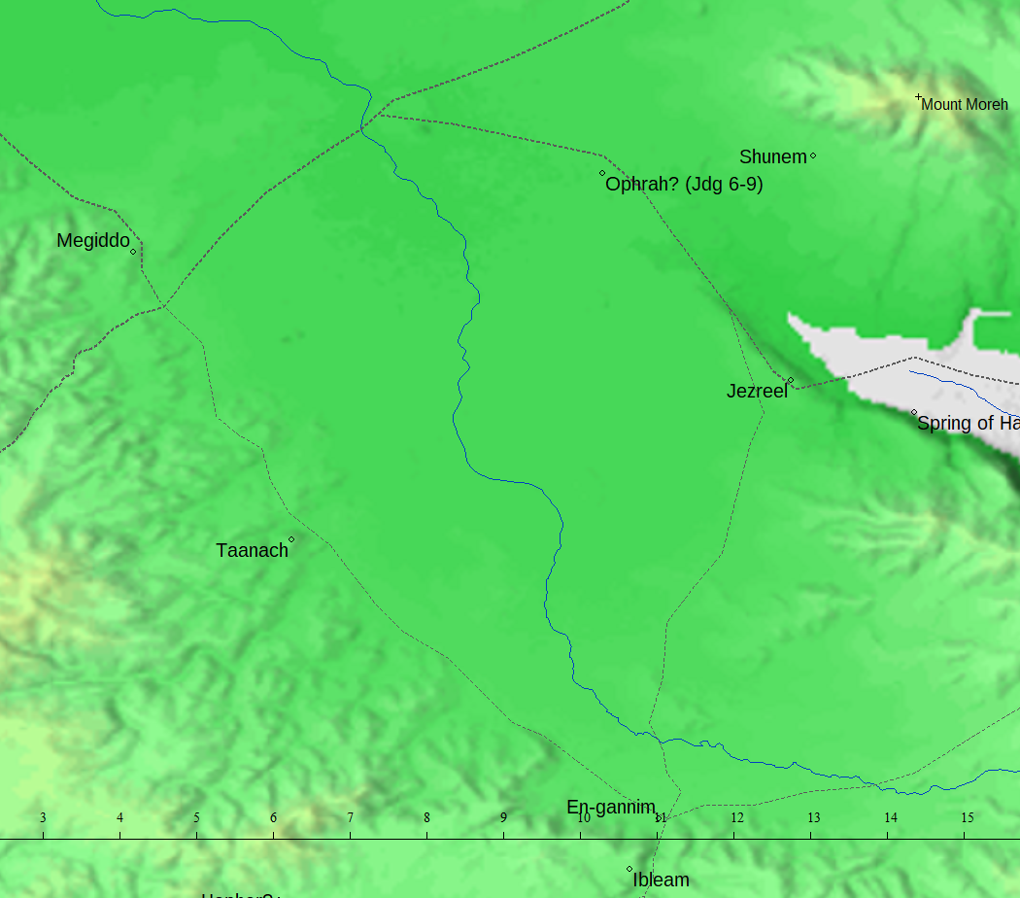

2 Kings 9:28,29
28 And his servants carried him in a chariot to Jerusalem, and buried him in his sepulchre with his fathers in the city of David.
29 And in the eleventh year of Joram the son of Ahab began Ahaziah to reign over Judah.
- Notice that right after the Ahaziah the son of Jehoram dies in Megiddo, we read about an Ahaziah whose reign began in the 11th year of Joram the son of Ahab.
  - We were just told in 2Ki 8:25 that the previous Ahaziah that was just killed began to reign in the 12th year of Joram the son of Ahab.
  - Thus, we are introduced to a second Ahaziah that began to reign before Ahaziah son of Jehoram.
- From the 11th year of Joram the son of Ahab to the 12th year is one year: therefore, the Ahaziah in 2Ki 8:25 and 2Ki 9:29 cannot be the same man because 20 years separate their age at the beginning of their reigns (2Ch 22:2).

2 Chronicles 17:7-9,12
7 Also in the third year of his reign he sent to his princes, even to Ben-hail, and to Obadiah, and to Zechariah, and to Nethaneel, and to Michaiah, to teach in the cities of Judah.
8 And with them he sent Levites, even Shemaiah, and Nethaniah, and Zebadiah, and Asahel, and Shemiramoth, and Jehonathan, and Adonijah, and Tobijah, and Tob-adonijah, Levites; and with them Elishama and Jehoram, priests.
9 And they taught in Judah, and had the book of the law of the LORD with them, and went about throughout all the cities of Judah, and taught the people.
¹² And Jehoshaphat waxed great exceedingly; and he built in Judah castles, and cities of store.
- Jehoshaphat sent some of his princes and Levites throughout Judah to teach from the book of the law of the LORD.

2 Chronicles 18:1-2
1 Now Jehoshaphat had riches and honour in abundance, and joined affinity with Ahab.
2 And after certain years he went down to Ahab to Samaria. And Ahab killed sheep and oxen for him in abundance, and for the people that he had with him, and persuaded him to go up with him to Ramoth-gilead.
- Joining affinity is an alliance through marriage (study the word affinity & H2859).
- After certain years Jehoshaphat goes and visits Ahab and Ahab hosts a large feast for Jehoshaphat and the people that he had with him.
- Might that have been a wedding feast?

2 Chronicles 19:1-2
1 And Jehoshaphat the king of Judah returned to his house in peace to Jerusalem.
2 And Jehu the son of Hanani the seer went out to meet him, and said to king Jehoshaphat, Shouldest thou help the ungodly, and love them that hate the LORD? therefore is wrath upon thee from before the LORD.
- After the battle with Syria where Ahab dies, Jehoshaphat is rebuked.

2 Chronicles 19:4
And Jehoshaphat dwelt at Jerusalem: and he went out again through the people from Beer-sheba to mount Ephraim, and brought them back unto the LORD God of their fathers.
- And then he goes on another missionary journey throughout Judah, Benjamin, and Ephraim.

2 Chronicles 21:1-4
1 Now Jehoshaphat slept with his fathers, and was buried with his fathers in the city of David. And Jehoram his son reigned in his stead.
2 And he had brethren the sons of Jehoshaphat, Azariah, and Jehiel, and Zechariah, and Azariah, and Michael, and Shephatiah: all these were the sons of Jehoshaphat king of Israel.
3 And their father gave them great gifts of silver, and of gold, and of precious things, with fenced cities in Judah: but the kingdom gave he to Jehoram; because he was the firstborn.
4 Now when Jehoram was risen up to the kingdom of his father, he strengthened himself, and slew all his brethren with the sword, and divers also of the princes of Israel.
- This is the only time that Jehoshephat king of Judah is called “king of Israel”.
- Those brethern of Jehoram were slain shortly after when he became king. This is a typical power move that ungodly men use to solidify their right to the throne (kill all the other candidates).
  - The Ahaziah in 2Ki 8:25 began to reign in the 7th year of Jehoram king of Judah’s reign.
    - The 12th year of Jehoram king of Israel’s reign.
  - The Ahaziah in 2Ki 9:29 began to reign in the 6th year of Jehoram king of Judah’s reign.
    - The 11th year of Jehoram king of Israel’s reign.
  - The Ahaziah in 2Ch 22:2 (42yrs old) cannot be Jehoram’s biological son.
    - Jehoram king of Judah began to reign at age 32 in the 5th year of Jehoram king of Israel who reigned for 12 years (2Ki 1:17, 3:1, 8:16).
    - Jehoram king of Israel began to reign in the 18th year of Jehoshaphat king of Judah who reigned for 25 years (1Ki 22:42, 2Ki 3:1, 2Ch 20:31).
      - Whether the Ahaziah in 2Ch 22:2 began to reign in the 6th or 7th year of Jehoram king of Judah’s reign (11th or 12th year of Jehoram king of Israel’s reign) that would put his birth year 3 or 2 years before Jehoram king of Judah was born.

2 Kings 10:4
But they were exceedingly afraid, and said, Behold, two kings stood not before him: how then shall we stand?
- The ruler’s of Jezreel acknowledged that Jehu had killed two kings already (Ahaziah 2Ki 8:25,26, 9:27 and Joram 2Ki 9:24).

II Chronicles 22:8  And it came to pass, that, when Jehu was executing judgment upon the house of Ahab, and found the princes of Judah, and the sons of the brethren of Ahaziah, that ministered to Ahaziah, he slew them. | 2Ki 10:1-11 | Ahab’s house cut off in both Jezreel & Samaria.
 | 2Ki 10:12-14 | Jehu goes to Samaria and slays the princes of Judah.
 | 2Ki 10:17 | Jehu slays all that remained unto Ahab in Samaria.
- Note that Ahaziah son of Ahab died from injuries from falling before Jehu came on the scene.

2 Chronicles 24:7
For the sons of Athaliah, that wicked woman, had broken up the house of God; and also all the dedicated things of the house of the LORD did they bestow upon Baalim.

